Public Water System Annual Report

-2025-

Name of the Public Water System: G3 Regional Water Co-op

Name of the Legal Owner: G3 Regional Water Co-operative Inc.

Contact Person: Lisa Pahl (Grandview CAO)

Phone: (204) 546-5250

Emergency number: (204) 546-5250

Name of Operators: Mr. Ivan Yakimishen & Mr. Michael Ukrainec

Phone during business hours: (204) 548-4561



Date Prepared: March 2026 ____________________________________
Lisa Pahl (Grandview CAO)
Secretary/Treasurer
G3 Regional Water Co-op Inc.
Table of Contents
1. Introduction: 3
2. Description of the Water System 3
2.1. Water Supply Source 3
2.2 Water Treatment Process 3
2.3 Classification and Certification 5
3. List of Water Quality Standards 5
4. Water System Incidents and Corrective Actions 6
5. Drinking Water Safety Orders, Warnings, and Charges 6
6. Major Expenses Incurred 6
7. Future System Expansion 7
8. Water Chemistry ………………………………………………………………………….13
Appendix A 8
Appendix B 17



Introduction:

The 2025 G3 Regional Water Co-op Annual Report summarizes the water utility’s ability to provide safe potable water and comply with provincial regulations.

Description of the Water System
The G3 Water Co-op provides potable drinking water to a population of approximately 2500 residents within the Municipalities of Grandview and Gilbert Plains, as well as supplying water to approximately 485 residents in the RM of Dauphin. No corrective actions or emergency reporting was required. Full sampling results are attached in Appendix A.

The G3 Regional Co-op water system consists of two wells, raw water supply pipeline, water treatment plant (WTP), and a network of distribution pipelines.

Water Supply Source
The G3 Regional Water Co-op receives its raw water supply from two 300 mm groundwater wells. The wells are located approximately 1 km north of the WTP on municipal right-of-way west of the NW 26-26-23 W. One well can supply the system; however, a fully equipped and redundant back-up well is provided to ensure supply can be always maintained.

Water Treatment Process
The treatment system is comprised of two parallel RO membrane filtration skids; manganese greensand bypass filter; and forced air degasification for carbon dioxide (CO₂) removal to provide pH adjustment. The treatment system ensures that the water meets the Guidelines for Canadian Drinking Water Quality and the provincial Drinking Water Safety Act.

The water treatment process is designed to reduce iron and manganese concentrations, ammonia reduction, and reduce hardness to an acceptable level. Iron and manganese are metals that cause laundry and plumbing fixture staining problems and can build up in the distribution pipes and cause reduced flow. Calcium carbonate (CaCO₃) causes hardness in water which diminishes the ability of the water to react with soap and form lather. Hardness also forms scale deposits in kettles and hot water tanks which can reduce the life expectancy of these appliances. Ammonia creates a high chlorine demand and complicates water disinfection where free chlorine residual must be maintained as the primary disinfectant.

Since membranes are capable of removing most of the hardness ions, a percentage of the raw water bypasses the membrane system and is filtered through a 2.1 m diameter manganese greensand pressure filter. Water passing through the pressure filter is blended with membrane permeate to produce the desired finished water hardness of approximately 100 mg/L (as CaCO₃).

The membranes reject approximately 25% concentrate water to Sulfur Spring Creek as permitted by Environment Act Licence No. 2853.

Potassium Permanganate is injected prior to the green sand filter to oxidize iron and manganese. Iron is precipitated and filtered out, while manganese is removed mostly by adsorption within the green sand layer of the pressure filter.

Antiscalant is injected in the membrane raw water supply to minimize RO membrane fouling by sequestering dissolved metals and minerals during the treatment and concentrate phases. Since membranes remove dissolved minerals, water stabilization through pH adjustment is required to produce a non-corrosive treated water supply. Forced air degasification is used to remove dissolved CO₂, which provides an efficient and economical method to increase pH while minimizing sodium hydroxide chemical usage.

The raw water supply contains ammonia which, unless removed through the treatment system, interferes with chlorine disinfection capability. Ammonia is removed through membrane treatment but not typically through the greensand filter. Chlorine for disinfection is added to maintain an adequate free chlorine residual concentration in the reservoir. Plant operators are required to test the water several times throughout the day at various points within the WTP to ensure break-point chlorination, required for water safety, is being achieved.

Treated water is stored in a 1200 cubic meter, three-cell reinforced concrete reservoir. The reservoir is equipped with ultrasonic level control and monitored with a SCADA system. The SCADA system also has the capability of monitoring and controlling reservoir levels located in the Grandview and Gilbert Plains and can monitor flow and pressures at booster stations in Mun. of Gilbert Plains and RM of Dauphin.

Corrosion inhibitor is added to the Municipality of Gilbert Plains line at their request to sequester any remaining metals in a dissolved state to minimize the probability of discoloured water in the distribution system.

A schematic of the water treatment process can be found in Appendix B.

Classification and Certification

The G3 Water Treatment Plant is a Class 2 Facility, and the G-3 Water Distribution System is a Class 2 System. The lead operator is classified as Class 2 treatment and
Class 2 distribution. The facility classifications are used to determine certification requirements for the water system operators as per the Manitoba Environment’s Water and Wastewater Facility Operators Regulation under the Environment Act.

List of Water Quality Standards

The Province of Manitoba has adopted several water quality standards from the Health Canada Guidelines for Canadian Drinking Water Quality. The G3 system is to meet the water quality standards as set in the G3 Operating License Table 1: Water Quality/Treatment Standards (see Table 1 below). The health-based parameters express the maximum acceptable concentrations for drinking water. Concentration values more than the guidelines constitute a health-related issue and require corrective actions.

Complete water chemistry analysis is only required every three years; however, testing was performed in 2025, and health-based parameters were within the limits for the G3 Regional Water System (see Appendix A). Public water systems are required to monitor chlorine levels and undertake regular bacterial testing. The G3 system met all requirements for water quality standards and monitoring requirements in 2025 and is fulfilling the requirements of their Operating Licence.
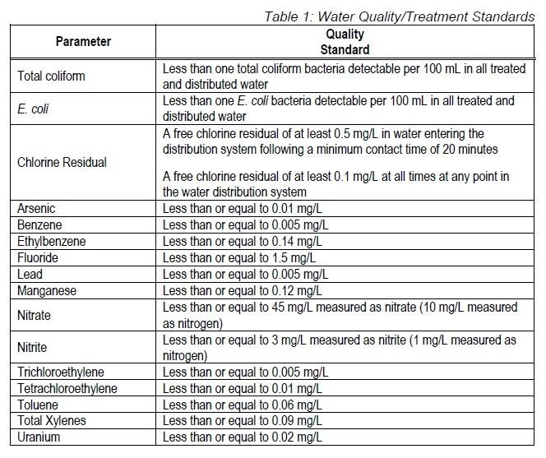

Water System Incidents and Corrective Actions
There were no corrective actions or emergency reporting required in 2025

Drinking Water Safety Orders, Warnings, and Charges
There were no Drinking Water Safety Orders or warnings issued in 2025, nor were any charges laid on the system.

Major Expenses Incurred
-Both Raw Wells by G3 WTP, new pumps & motors, stainless steel casing installed (Completed Dec 2025)
-Moved electrical panel at Raw Well Site by G3 WTP, new wiring to transfer switch installed (Completed Oct 2025)
-New SCADA System & 2 new computers for the G3 WTP (Completed Dec 2025)
-Concentrate Valves on both MTU’s Replaced/Upgraded (Completed Sept 2025)
-New SonicWall Boxes installed for communication at G3 WTP, GV Reservoir, GP Reservoir, GP Booster Station (Completed Oct 2025)
-New Internet Provider at G3 WTP (Hardware Installation & Service Turned On)
(Completed Oct 2025)
-New Hach HQ2200 pH/Conductivity Meter for G3 WTP (Received May 2025)

Future System Expansion
The water distribution system will continue expansion into the RM of Gilbert Plains & RM of Dauphin (at their cost for capital expenditures), increasing the number of customers in the
G-3 Co-op.

The G-3 member municipalities plan to continue expansion of their distribution networks as funding opportunities arise and finances are available.

Appendix A

Results of Water Chemistry, Bacterial and
Chlorine Residual Analysis



Chlorine Residual and TC/EC Analyses

Collection Date | Sample Identification | TC | EC | CL2 Free | CL2 Total
2025-01-07 | G3 1 - RAW | 0 | 0 | na | na
2025-01-07 | G3 2 - TREATED | 0 | 0 | 0.94 | 1.02
2025-01-07 | G3 3 - DISTRIBUTION Gilbert Plains | 0 | 0 | 0.90 | 0.94
2025-01-14 | G3 1 - RAW | 0 | 0 | na | na
2025-01-14 | G3 2 - TREATED | 0 | 0 | 0.87 | 0.94
2025-01-14 | G3 3 - DISTRIBUTION Gilbert Plains | 0 | 0 | 0.86 | 0.89
2025-01-29 | G3 1 - RAW | 0 | 0 | na | na
2025-01-29 | G3 2 - TREATED | 0 | 0 | 0.95 | 1.02
2025-01-29 | G3 3 - DISTRIBUTION Gilbert Plains | 0 | 0 | 0.85 | 0.94
2025-02-12 | G3 1 - RAW | 0 | 0 | na | na
2025-02-12 | G3 2 - TREATED | 0 | 0 | 0.94 | 1.03
2025-02-12 | G3 3 - DISTRIBUTION Gilbert Plains | 0 | 0 | 0.92 | 0.94
2025-02-26 | G3 1 - RAW | 0 | 0 | na | na
2025-02-26 | G3 2 - TREATED | 0 | 0 | 0.94 | 0.98
2025-02-26 | G3 3 - DISTRIBUTION Gilbert Plains | 0 | 0 | 0.88 | 0.89
2025-03-12 | G3 1 - RAW | 0 | 0 | na | na
2025-03-12 | G3 2 - TREATED | 0 | 0 | 0.92 | 0.99
2025-03-12 | G3 3 - DISTRIBUTION Gilbert Plains | 0 | 0 | 0.91 | 0.93
2025-04-09 | G3 1 - RAW | 0 | 0 | na | na
2025-04-09 | G3 2 - TREATED | 0 | 0 | 0.98 | 1.04
2025-04-09 | G3 3 - DISTRIBUTION Gilbert Plains | 0 | 0 | 0.93 | 0.98
2025-04-23 | G3 1 - RAW | 0 | 0 | na | na
2025-04-23 | G3 2 - TREATED | 0 | 0 | 0.93 | 1.04
2025-04-23 | G3 3 - DISTRIBUTION Gilbert Plains | 0 | 0 | 0.86 | 0.89
2025-05-07 | G3 1 - RAW | 0 | 0 | na | na
2025-05-07 | G3 2 - TREATED | 0 | 0 | 0.96 | 1.09
2025-05-07 | G3 3 - DISTRIBUTION Gilbert Plains | 0 | 0 | 0.85 | 0.90
2025-05-21 | G3 1 - RAW | 0 | 0 | na | na
2025-05-21 | G3 2 - TREATED | 0 | 0 | 0.95 | 1.03
2025-05-21 | G3 3 - DISTRIBUTION Gilbert Plains | 0 | 0 | 0.89 | 0.95

Collection Date | Sample Identification | TC | EC | CL2 Free | CL2 Total
2025-06-04 | G3 1 - RAW | 0 | 0 | na | na
2025-06-04 | G3 2 - TREATED | 0 | 0 | 0.95 | 1.08
2025-06-04 | G3 3 - DISTRIBUTION Gilbert Plains | 0 | 0 | 0.96 | 0.99
2025-06-18 | G3 1 - RAW | 0 | 0 | na | na
2025-06-18 | G3 2 - TREATED | 0 | 0 | 0.95 | 1.13
2025-06-18 | G3 3 - DISTRIBUTION Gilbert Plains | 0 | 0 | 0.84 | 0.92
2025-07-03 | G3 1 - RAW | 0 | 0 | na | na
2025-07-03 | G3 2 - TREATED | 0 | 0 | 0.92 | 1.06
2025-07-03 | G3 3 - DISTRIBUTION Gilbert Plains | 0 | 0 | 0.89 | 0.97
2025-07-16 | G3 1 - RAW | 0 | 0 | na | na
2025-07-16 | G3 2 - TREATED | 0 | 0 | 1.05 | 1.12
2025-07-16 | G3 3 - DISTRIBUTION Gilbert Plains | 0 | 0 | 0.92 | 0.95
2025-07-30 | G3 1 - RAW | 0 | 0 | na | na
2025-07-30 | G3 2 - TREATED | 0 | 0 | 0.96 | 1.00
2025-07-30 | G3 3 - DISTRIBUTION Gilbert Plains | 0 | 0 | 0.87 | 0.92
2025-08-13 | G3 1 - RAW | 0 | 0 | na | na
2025-08-13 | G3 2 - TREATED | 0 | 0 | 0.92 | 1.01
2025-08-13 | G3 3 - DISTRIBUTION Gilbert Plains | 0 | 0 | 0.91 | 0.94
2025-08-27 | G3 1 - RAW | 0 | 0 | na | na
2025-08-27 | G3 2 - TREATED | 0 | 0 | 0.96 | 1.12
2025-08-27 | G3 3 - DISTRIBUTION Gilbert Plains | 0 | 0 | 0.80 | 0.82
2025-09-10 | G3 1 - RAW | 0 | 0 | na | na
2025-09-10 | G3 2 - TREATED | 0 | 0 | 0.82 | 0.90
2025-09-10 | G3 3 - DISTRIBUTION Gilbert Plains | 0 | 0 | 0.84 | 0.85
Collection Date | Sample Identification | TC | EC | CL2 Free | CL2 Total
2025-09-24 | G3 1 – RAW | 0 | 0 | na | na
2025-09-24 | G3 2 - TREATED | 0 | 0 | 0.98 | 1.06
2025-09-24 | G3 3 - DISTRIBUTION Gilbert Plains | 0 | 0 | 0.82 | 0.84
2025-10-08 | G3 1 - RAW | 0 | 0 | na | na
2025-10-08 | G3 2 - TREATED | 0 | 0 | 0.95 | 1.07
2025-10-08 | G3 3 - DISTRIBUTION Gilbert Plains | 0 | 0 | 0.86 | 0.89
2025-10-22 | G3 1 - RAW | 0 | 0 | na | na
2025-10-22 | G3 2 - TREATED | 0 | 0 | 0.98 | 1.08
2025-10-22 | G3 3 - DISTRIBUTION Gilbert Plains | 0 | 0 | 0.89 | 0.92
2025-11-05 | G3 1 - RAW | 0 | 0 | na | na
2025-11-05 | G3 2 - TREATED | 0 | 0 | 1.09 | 1.19
2025-11-05 | G3 3 - DISTRIBUTION Gilbert Plains | 0 | 0 | 0.83 | 0.91

2025-11-19 | G3 1 - RAW | 0 | 0 | na | na
2025-11-19 | G3 2 - TREATED | 0 | 0 | 0.94 | 1.04
2025-11-19 | G3 3 - DISTRIBUTION Gilbert Plains | 0 | 0 | 0.90 | 0.96
2025-12-03 | G3 1 – RAW | 0 | 0 | na | na
2025-12-03 | G3 2 – TREATED | 0 | 0 | 0.97 | 1.05
2025-12-03 | G3 3 - DISTRIBUTION Gilbert Plains | 0 | 0 | 0.87 | 0.91
2025-12-30 | G3 1 – RAW | 0 | 0 | na | na
2025-12-30 | G3 2 – TREATED | 0 | 0 | 0.93 | 1.01
2025-12-30 | G3 3 - DISTRIBUTION Gilbert Plains | 0 | 0 | 0.94 | 0.98

Notes:
CL2: Reported in units of mg/L
TC/EC: Reported in units of MPN/100 mL

Water Chemistry

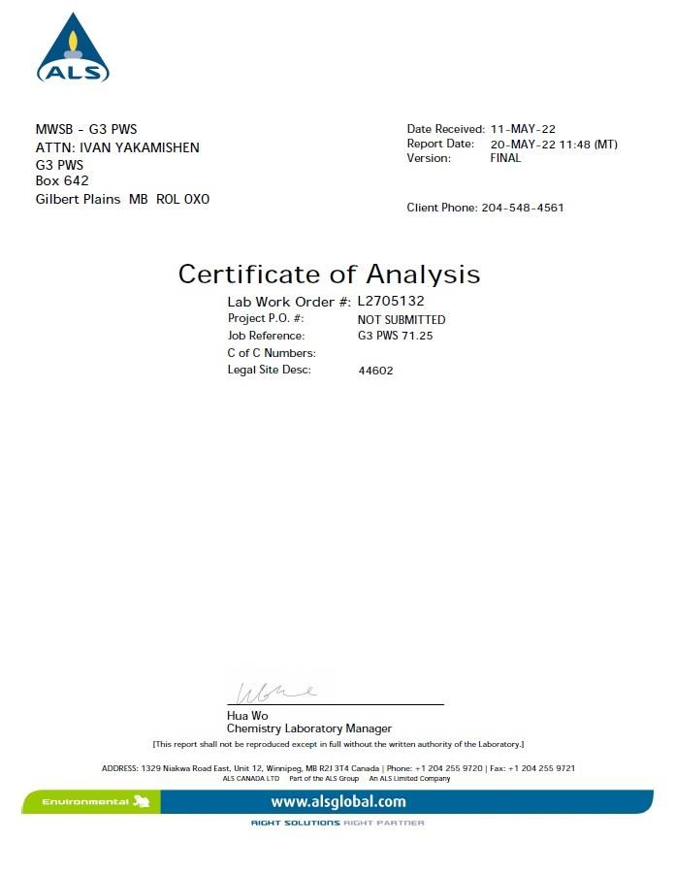
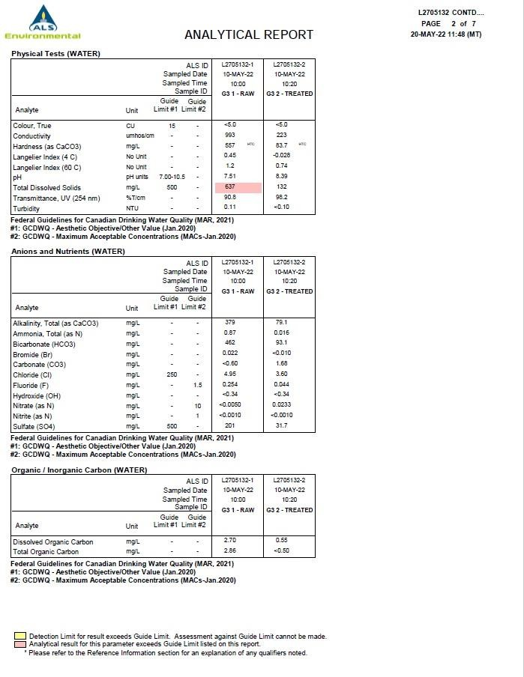
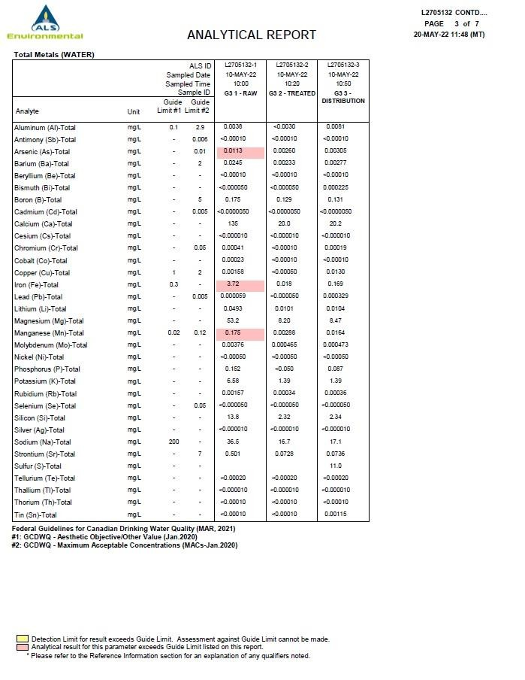

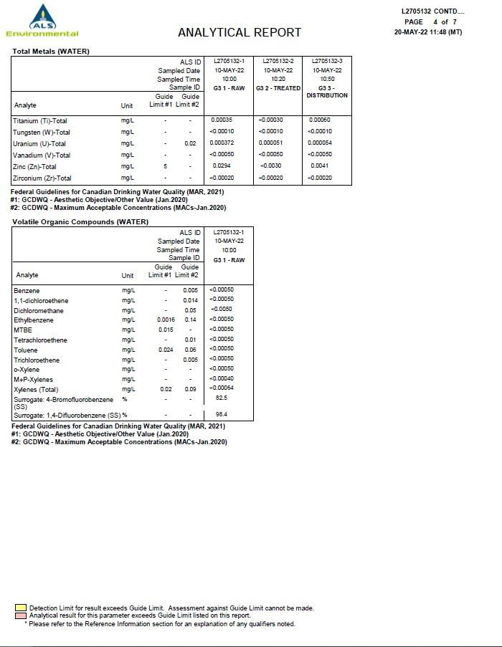

Appendix B

Water Treatment Plant Process Diagram
Pipeline Schematic



